**DUAL BOOTING EXERCISE 1**

we start by opening windows in virtualbox and we will see how the two operating systems appear.

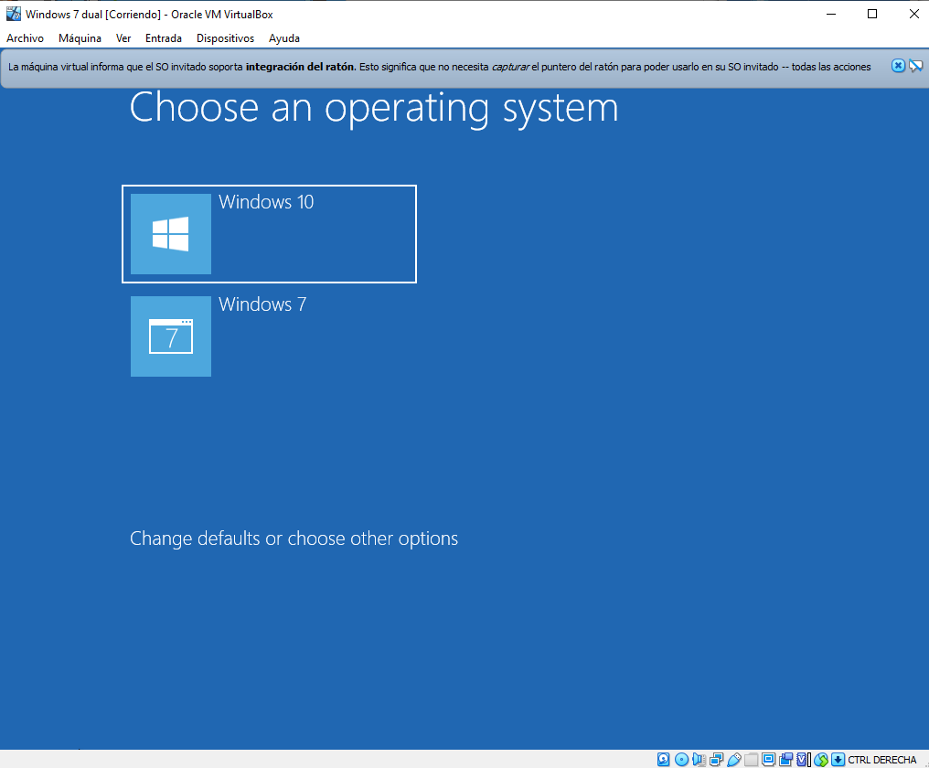

To set windows 7 by default, click on “Change defaults or choose options”

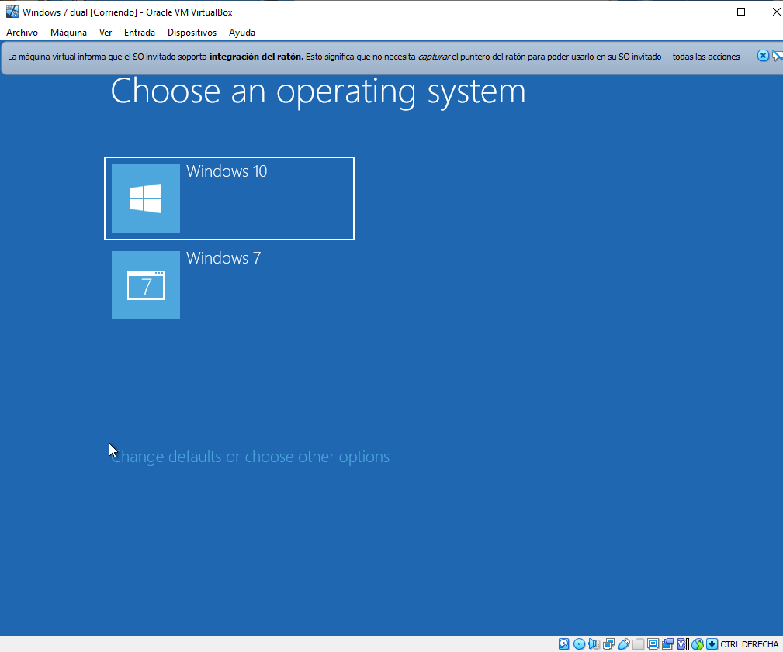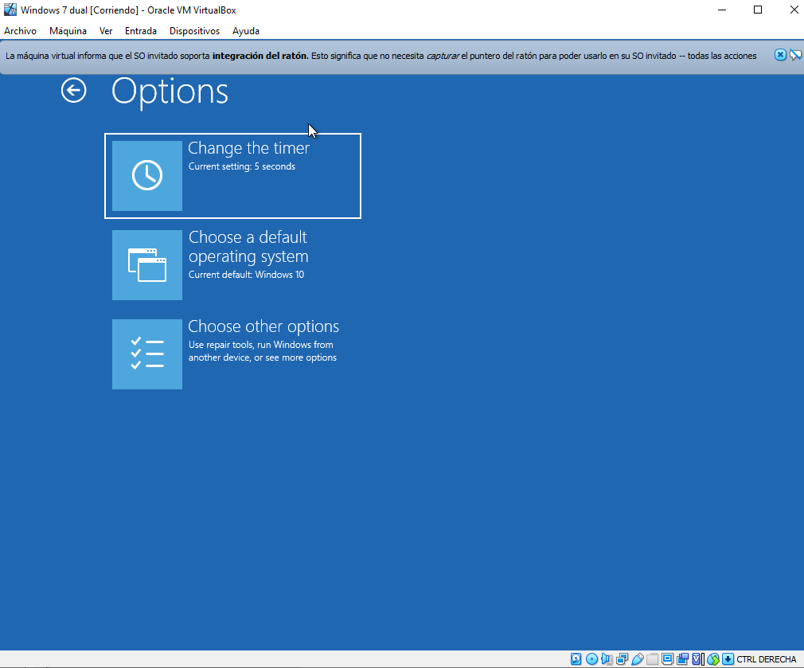

Finally we select the default operating system in this case we select windows 7.

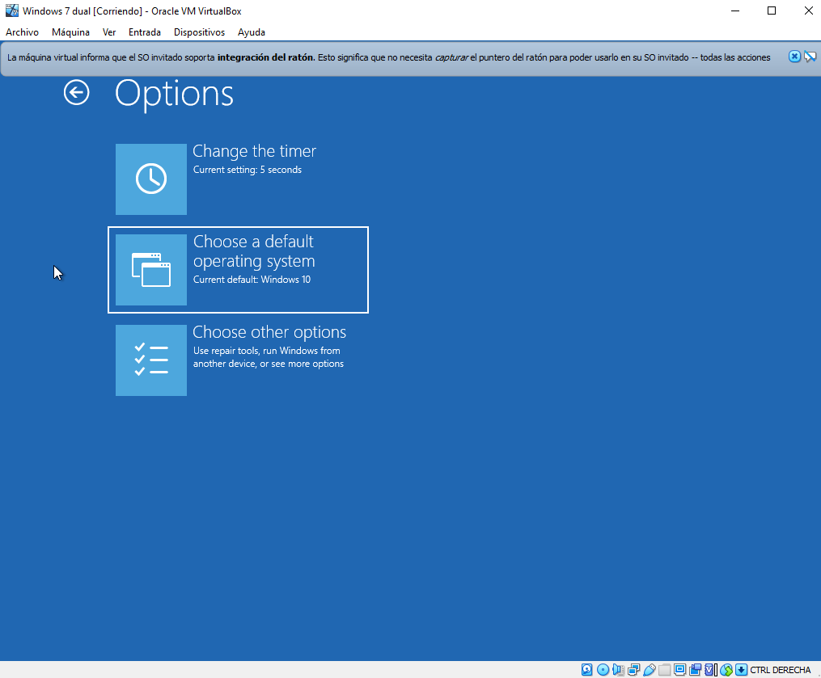

**EXERCISE 2**

To change the default startup time and the default operating system, we start by opening the command line:

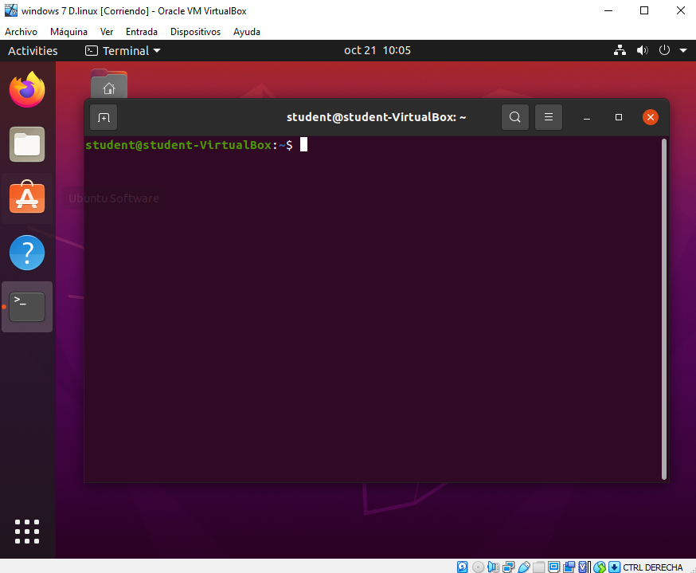

Then we put the command line to give permissions " sudo su ". (Keep in mind that the password will not appear on the screen).

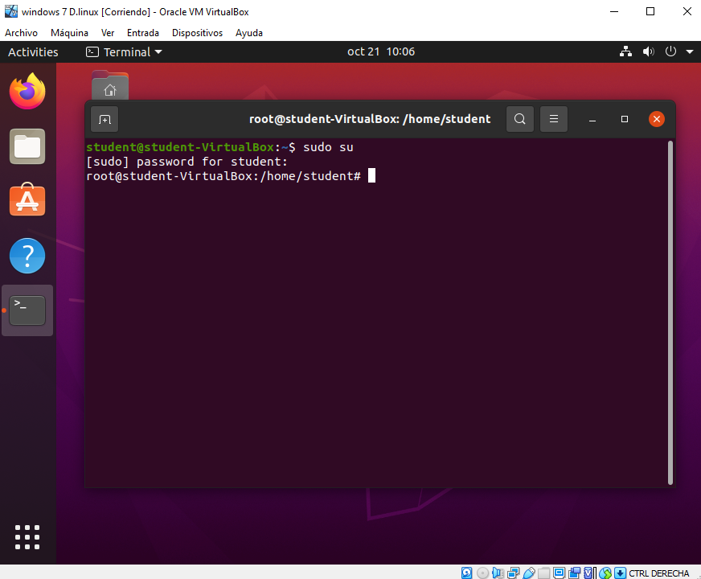

Once we have permissions we put the following command "sudo nano / etc / default / grub" and we change the line from "GRUB_DEFAULT" to “4” and also "GRUB_TIMEOUT" to 15 seconds.

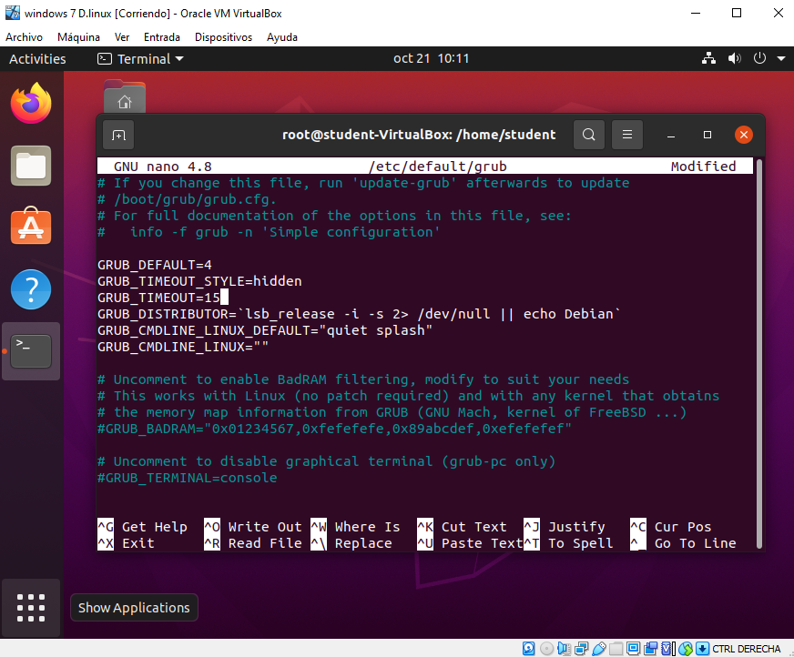

Finally we restart and we see that by default " WINDOWS 7 " starts in 15 seconds.

